|  |
| --- |
| **Database Signalling** |

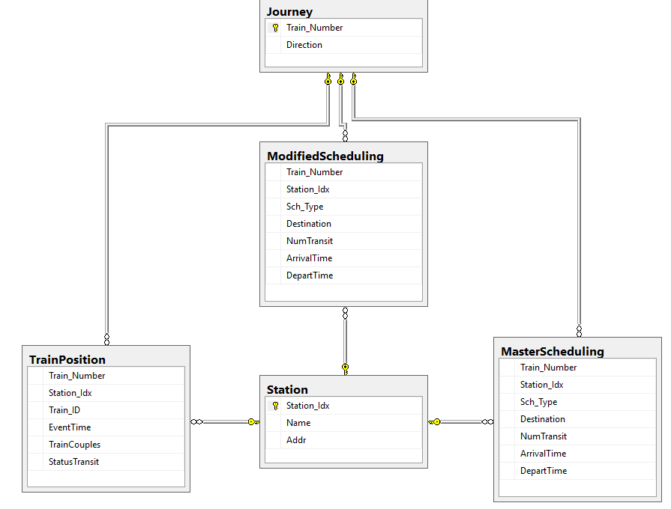

Deskripsi masing-masing table

1. **JOURNEY**

- Train Number untuk mendeskripsikan id perlajalan kereta.

- Direction awal keberangkatan kereta

1. **MODIFIEDSCHEDULING  
   -** Train Number untuk mendeskripsikan detail dari table journey.  
   - Station Index untuk mendeskripsikan id stasiun.  
   - Schtype untuk mendeskripsikan tipe shchedule seperti Weekday,holiday,special.  
   - Destination untuk tujuan akhir kereta.  
   - NumTransit jumlah stasiun yang di kunjungi.  
   - ArrivalTime waktu tempuh kereta akan sampai pada tujuan.  
   - DepartTime waktu tempuh kereta awal perjalanan.
2. **STATION**- Station Index untuk mendeskripsikan id stasiun.  
   - Name untuk mendeskripsikan nama stasiun.  
   - Addr untuk mendeskripsikan alamat stasiun.
3. **TRAINPOSITION**- Train Number mendeskripsikan detail dari table journey.  
   - Station Index untuk mendeskripsikan posisi kereta pada keberangkatan kereta.  
   - Train ID mendeskripsikan gabungan train.  
   - EventTime untuk mendeskripsikan waktu dari saat terjadi trainposition.  
   - TrainCouples untuk mendeskripsikan jumlah gerbong kereta.  
   - Status Transit untuk mendeskripsikan saat kejadian kereta seperti Approach,Depart,Arrived.
4. **MASTERSCHEDULING**

**-** Train Number untuk mendeskripsikan detail dari table journey.  
- Station Index untuk mendeskripsikan id stasiun.  
- Schtype untuk mendeskripsikan tipe shchedule seperti Weekday,holiday,special.  
- Destination untuk tujuan akhir kereta.  
- NumTransit jumlah stasiun yang di kunjungi.  
- ArrivalTime waktu tempuh kereta akan sampai pada tujuan.  
- DepartTime waktu tempuh kereta awal perjalanan.

SQL SCRIPT TABLE

1. JOURNEY TABLE

CREATE TABLE [dbo].[Journey](

[Train_Number] [char](4) NOT NULL,

[Direction] [varchar](50) NULL,

PRIMARY KEY CLUSTERED

(

[Train_Number] ASC

)WITH (PAD_INDEX = OFF, STATISTICS_NORECOMPUTE = OFF, IGNORE_DUP_KEY = OFF, ALLOW_ROW_LOCKS = ON, ALLOW_PAGE_LOCKS = ON) ON [PRIMARY]

) ON [PRIMARY]

1. MODIFIED SCHEDULING

CREATE TABLE [dbo].[ModifiedScheduling](

[Train_Number] [char](4) NOT NULL,

[Station_Idx] [char](4) NOT NULL,

[Sch_Type] [varchar](50) NULL,

[Destination] [varchar](50) NULL,

[NumTransit] [varchar](50) NULL,

[ArrivalTime] [varchar](50) NULL,

[DepartTime] [varchar](50) NULL

) ON [PRIMARY]

GO

SET ANSI_PADDING OFF

GO

ALTER TABLE [dbo].[ModifiedScheduling] WITH CHECK ADD CONSTRAINT [FK_ModifiedScheduling_Station] FOREIGN KEY([Station_Idx])

REFERENCES [dbo].[Station] ([Station_Idx])

GO

ALTER TABLE [dbo].[ModifiedScheduling] CHECK CONSTRAINT [FK_ModifiedScheduling_Station]

GO

ALTER TABLE [dbo].[ModifiedScheduling] WITH CHECK ADD CONSTRAINT [FK_ModifiedScheduling_Train] FOREIGN KEY([Train_Number])

REFERENCES [dbo].[Journey] ([Train_Number])

GO

ALTER TABLE [dbo].[ModifiedScheduling] CHECK CONSTRAINT [FK_ModifiedScheduling_Train]

GO

1. STATION

CREATE TABLE [dbo].[Station](

[Station_Idx] [char](4) NOT NULL,

[Name] [varchar](50) NULL,

[Addr] [varchar](50) NULL,

CONSTRAINT [PK__Station__2AB990911465742F] PRIMARY KEY CLUSTERED

(

[Station_Idx] ASC

)WITH (PAD_INDEX = OFF, STATISTICS_NORECOMPUTE = OFF, IGNORE_DUP_KEY = OFF, ALLOW_ROW_LOCKS = ON, ALLOW_PAGE_LOCKS = ON) ON [PRIMARY]

) ON [PRIMARY]

GO

SET ANSI_PADDING OFF

GO

1. TRAIN POSITION

CREATE TABLE [dbo].[TrainPosition](

[Train_Number] [char](4) NOT NULL,

[Station_Idx] [char](4) NULL,

[Train_ID] [char](3) NULL,

[EventTime] [varchar](50) NULL,

[TrainCouples] [varchar](50) NULL,

[StatusTransit] [varchar](50) NULL

) ON [PRIMARY]

GO

SET ANSI_PADDING OFF

GO

ALTER TABLE [dbo].[TrainPosition] WITH CHECK ADD CONSTRAINT [FK_TrainPosition_Station] FOREIGN KEY([Station_Idx])

REFERENCES [dbo].[Station] ([Station_Idx])

GO

ALTER TABLE [dbo].[TrainPosition] CHECK CONSTRAINT [FK_TrainPosition_Station]

GO

ALTER TABLE [dbo].[TrainPosition] WITH CHECK ADD CONSTRAINT [FK_TrainPosition_Train] FOREIGN KEY([Train_Number])

REFERENCES [dbo].[Journey] ([Train_Number])

GO

ALTER TABLE [dbo].[TrainPosition] CHECK CONSTRAINT [FK_TrainPosition_Train]

GO

1. MASTER SCHEDULING

CREATE TABLE [dbo].[MasterScheduling](

[Train_Number] [char](4) NOT NULL,

[Station_Idx] [char](4) NOT NULL,

[Sch_Type] [varchar](50) NULL,

[Destination] [varchar](50) NULL,

[NumTransit] [varchar](50) NULL,

[ArrivalTime] [varchar](50) NULL,

[DepartTime] [varchar](50) NULL

) ON [PRIMARY]

GO

SET ANSI_PADDING OFF

GO

ALTER TABLE [dbo].[MasterScheduling] WITH CHECK ADD CONSTRAINT [FK_Scheduling_Station] FOREIGN KEY([Station_Idx])

REFERENCES [dbo].[Station] ([Station_Idx])

GO

ALTER TABLE [dbo].[MasterScheduling] CHECK CONSTRAINT [FK_Scheduling_Station]

GO

ALTER TABLE [dbo].[MasterScheduling] WITH CHECK ADD CONSTRAINT [FK_Scheduling_Train] FOREIGN KEY([Train_Number])

REFERENCES [dbo].[Journey] ([Train_Number])

GO

ALTER TABLE [dbo].[MasterScheduling] CHECK CONSTRAINT [FK_Scheduling_Train]

GO